EVC indicator issue- All lights are on but no error is reported.

Author:Wesley
Reviewer:Eason

FAQ\EVC
Issue introduction
All EVC indicators are on but no error is reported.
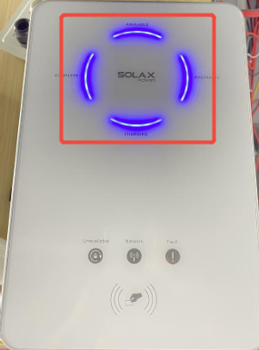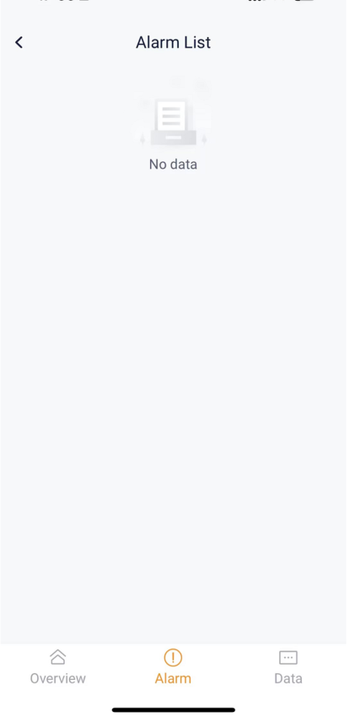
Confirmation of basic information
[Photo] SN number of the EVC.
Guidance for installer
Step 1: Contact the SolaX technical support team to send you the latest version of firmware and the file name contains ‘ARM’.
Step 2: Create an ‘upgrade’ file in the USB flash drive, create an ‘ARM’ file in the upgrade file, and put the latest firmware version in the ‘ARM’ file.

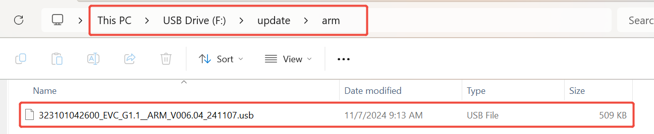
Step 3: Insert the USB flash drive into the USB port.
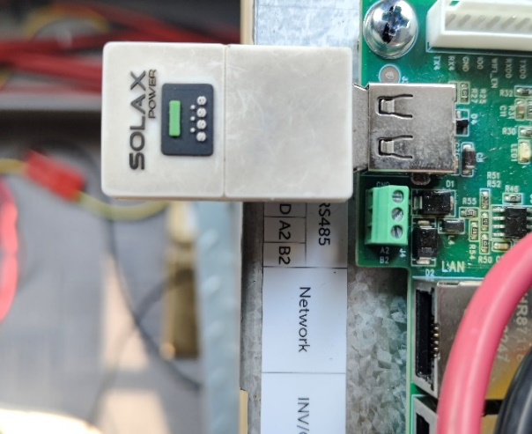
Wait a moment, and then all the indicators will flash once, which means the upgrade has begun.
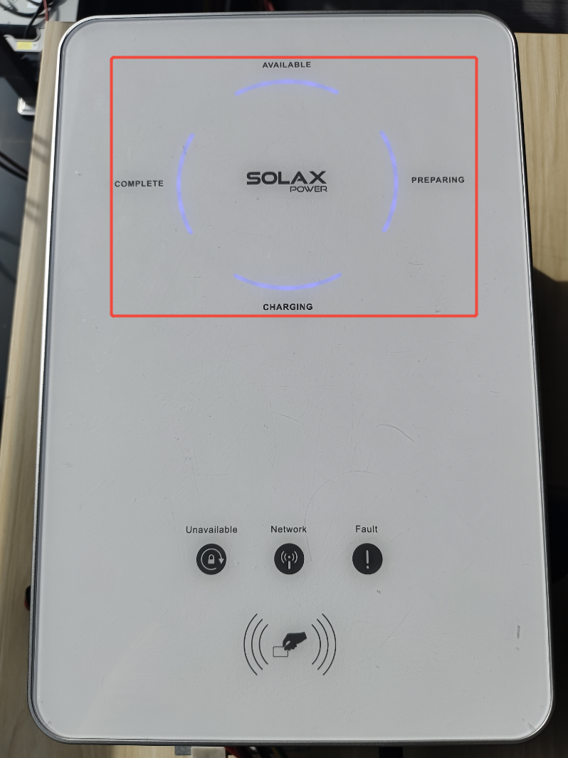
When only the Available indicator is still on, it means that the upgrade has completed successfully.
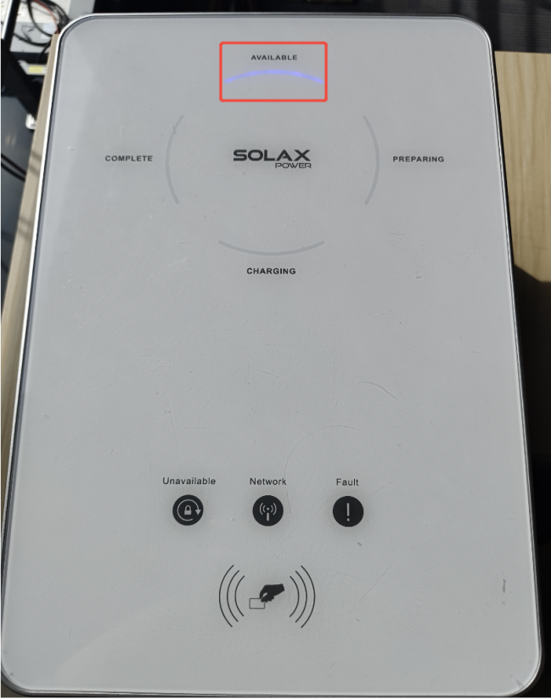
Information check list
If you have completed the above <Guidance for installer>, and the problem is still not solved, please collect the following troubleshooting information and send them to the Solax technical support team.
1. [Photo]EVC information including SN and registration numbers.
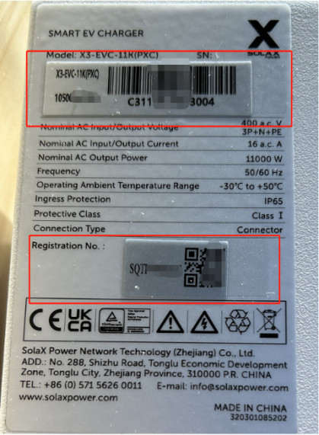
2.[Photo]The indicators of the EVC.



